Build_prompt2.py
build_prompt is a small generator, give it operands, an operation symbol, a wording, and a surface-form choice, and it assembles the actual sentence. The four dict entries are your four comparison axes, each built by holding an "anchor" configuration fixed (5 & 9, multiplication, "Calculate", symbol form) and varying exactly one thing against it. operation_only compares the anchor prompt against each of the other three operations; wording_only compares it against the other two wordings; operand_only compares the anchor's operand pair against your other two operand pairs; surface_form_only compares symbol-form against word-form for each operand set.
wording_only: 6 pairs
'Calculate 5 × 9' vs 'Compute 5 × 9'
'Calculate 5 × 9' vs 'What is 5 × 9'
'Calculate 14 × 20' vs 'Compute 14 × 20'
'Calculate 14 × 20' vs 'What is 14 × 20'
'Calculate 10 × 16' vs 'Compute 10 × 16'
'Calculate 10 × 16' vs 'What is 10 × 16'

operation_only: 9 pairs
'Calculate 5 × 9' vs 'Calculate 5 + 9'
'Calculate 5 × 9' vs 'Calculate 5 - 9'
'Calculate 5 × 9' vs 'Calculate 5 ÷ 9'
'Calculate 14 × 20' vs 'Calculate 14 + 20'
'Calculate 14 × 20' vs 'Calculate 14 - 20'
'Calculate 14 × 20' vs 'Calculate 14 ÷ 20'
'Calculate 10 × 16' vs 'Calculate 10 + 16'
'Calculate 10 × 16' vs 'Calculate 10 - 16'
'Calculate 10 × 16' vs 'Calculate 10 ÷ 16'

operand_only: 2 pairs
'Calculate 5 × 9' vs 'Calculate 14 × 20'
'Calculate 5 × 9' vs 'Calculate 10 × 16'

surface_form_only: 3 pairs
'Calculate 5 × 9' vs 'Calculate 5 times 9'
'Calculate 14 × 20' vs 'Calculate 14 times 20'
'Calculate 10 × 16' vs 'Calculate 10 times 16'

Extract_midlayers.py
axis | pair | last-tok avg | mean-pool avg
------------------------------------------------------------
wording_only | 0 | 0.9914 | 0.9999
wording_only | 1 | 0.9753 | 0.9996
wording_only | 2 | 0.9930 | 0.9999
wording_only | 3 | 0.9813 | 0.9995
wording_only | 4 | 0.9936 | 0.9999
wording_only | 5 | 0.9801 | 0.9995
operation_only | 0 | 0.9358 | 0.9999
operation_only | 1 | 0.9107 | 0.9999
operation_only | 2 | 0.8832 | 0.9998
operation_only | 3 | 0.9336 | 0.9998
operation_only | 4 | 0.8971 | 0.9998
operation_only | 5 | 0.8919 | 0.9997
operation_only | 6 | 0.9322 | 0.9998
operation_only | 7 | 0.9038 | 0.9998
operation_only | 8 | 0.9101 | 0.9997
operand_only | 0 | 0.7285 | 0.9997
operand_only | 1 | 0.7686 | 0.9997
surface_form_only | 0 | 0.9616 | 0.9999
surface_form_only | 1 | 0.9682 | 0.9999
surface_form_only | 2 | 0.9671 | 0.9999

wording_only (~0.975–0.994) and surface_form_only (~0.96–0.97), both very high, barely different from "identical prompt." Changing the verb ("Calculate" vs "Compute" vs "What is") or changing how the operator is written ("×" vs "times") barely moves the representation at all.
operation_only (~0.88–0.94), a real, visible drop. Swapping the actual arithmetic operation, holding operands and wording fixed, pulls the representation meaningfully further apart than any wording or surface change did.
operand_only (~0.73–0.77), the lowest by a clear margin. Changing the actual numbers, even keeping operation and wording identical, causes the biggest shift of all four axes.
- The wording, surface form doesn’t matter much to the representation, while the actual math context (numbers and operation) matters a lot more, and operand matters even more than the operation.

Hiddenlayers_plot.py
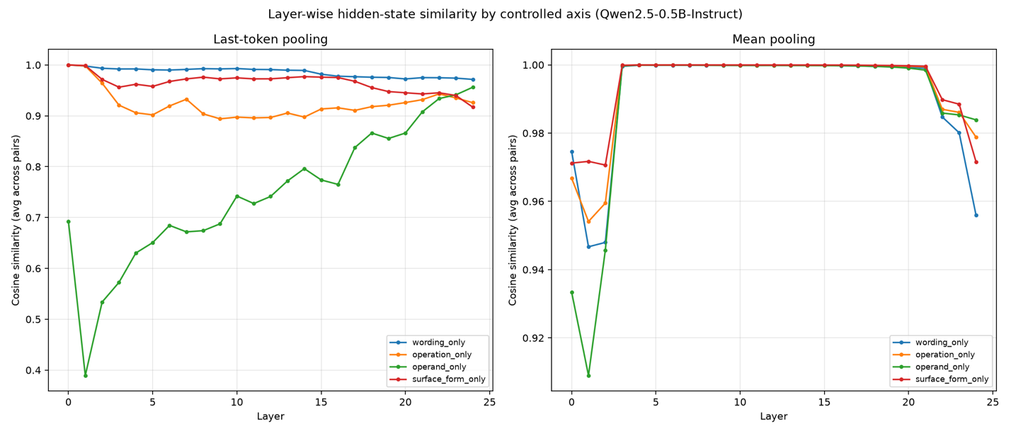
Building on the wording/meaning stuff from last time, I set up a more controlled test. Instead of loosely grouping prompts by "feels similar" vs "feels different," I built 20 pairs where I only ever change one thing at a time, either the wording, how the operator is written (× vs "times"), the actual operation (+/-/×/÷), or the operands themselves. Everything else stays identical. I also made sure every prompt ends on the same final word this time, since last round I found out that mismatched endings were messing with the similarity scores regardless of meaning.
Mean-pooling again saturates near 1.0 for every axis in the middle layers, now a repeated, established limitation, not a one-off.
Last-token pooling clearly separates the axes: wording and surface form barely shift the representation (0.96–0.99 avg similarity), while operation and operands cause much larger shifts (0.73–0.94), the model tracks computational content more than phrasing.
The layer-by-layer plot showed something I didn't expect: operand changes cause a huge drop right away (makes sense, different numbers = different tokens) but then it climbs back up steadily and actually ends up MORE similar than wording/surface-form by the last layers. Operation changes, though, stay separated the whole way through and don't recover like that.
The last 2–3 layers are noisy across the board, likely reflecting next-token-prediction specialization; conclusions lean on the stable layers ~3–20.
Once I control for wording and how stuff's written, the hidden states really do seem to care more about the actual math than the phrasing, which is what we want if we're eventually trying to spot "this is really the same computation" regardless of how someone asks. The operand-vs-operation thing is new and kind of interesting, feels like a good next thing to dig into, maybe by trying to actually decode the operation from the hidden states directly instead of just measuring similarity.

